# Objectives

* + All prior guided practices completed.

## Skills graded

* + Create User accounts.
  + Create user profile
  + Create shared folders.
  + Assign appropriate NTFS permissions.
  + Create and assign printers.
  + Create a VHD

# Initial Conditions

Your virtual machine should be in this state prior to beginning this performance assessment:

* + Use **GE-SERVER** VM created for the first performance assessment**.**
    - IP address range of **172.16.*X*.0 /24** for LAN network. **SERVER** will host DNS. DNS client is configured using the DNS server on **SERVER.**
    - Active Directory Domain Services installed and configured as **GE.local**.
    - Passwords **Administrator –** Password1 (admin user)
    - GE-SERVER is running
  + **GE1** – VM is running
  + All other VMs are shutdown.

# Instructions

Perform the following:

* Download the **PA2-Create-Topology.ps1** file to the **C:\Scripts** folder.
* On you **VMHost** machine, open **Powershell**.
* In PowerShell, enter the command below to create the network for the Performance Assessment.

1. C:\Scripts\PA2-Create-Topology.ps1

This script will create **GE2** VM from a Windows 10 image. **GE-SERVER** and **GE1** were created in the previous performance assessment.

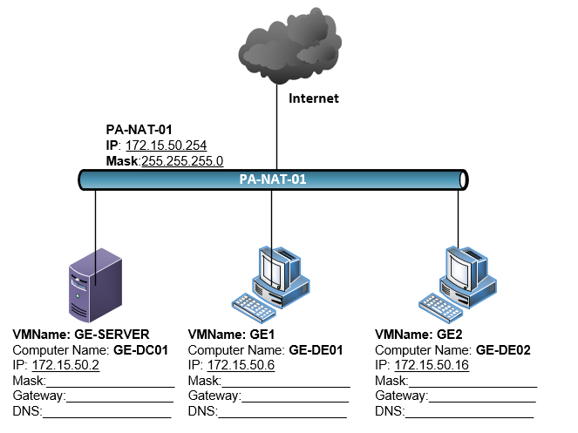

1. Perform initial startup on **GE2**. Set the initial user to **student** with a password of **Password1**.
   1. Stop **Windows Update** service and set the **Startup type** to **Manual**.
2. Rename NIC on **GE2** to **LAN**.
3. You are assigned the IP address range of **172.15.50.16 /24** for this graded exercise. On **GE2**, configure **LAN** NIC with the IP address, gateway, and subnet mask. **GE-SERVER** hosts DNS. Configure the DNS client on **GE2** to use the DNS server on **GE-SERVER.**
4. Rename **GE2** to **GE2-DE02**.
5. Join **GE2** to your domain.
6. Create the users in your organization.

|  |  |  |  |  |  |
| --- | --- | --- | --- | --- | --- |
| **First Name** | **Last Name** | **Full Name** | **Logon**  **Name** | **Logon Name**  **(Pre-W2K)** | **Password** |
| Barry | Gorn | Barry Gorn | bgorn | bgorn | Password1 |
| Jimmy | Hill | Jimmy Hill | Jhill | Jhill | Password1 |
| Jack | Mack | Jack Mack | jmack | jmack | Password1 |
| Edwin | Gurley | Edwin Gurley | egurley | egurley | Password1 |
| Latisha | Bach | Latisha Bach | lbach | lback | Passowrd1 |
| Gail | Crump | Gail Crump | gcrump | gcrump | Password1 |

1. Create a **Domain Administrative** account for yourself. Use your first and last name for the account. Use your ***studentID*** for the Logon Name.
2. Create users and add to the appropriate global groups.

|  |  |
| --- | --- |
| **Global Group Name** | **Members** |
| **GSBO-Sales** | Barry Gorn, Edwin Gurley |
| **GSBO-Services** | Jack Mack, Gail Crump |
| **GRVL-Sales** | Jimmy Hill, Latisha Bach |

1. In Hyper-V create (2) dynamically expanding virtual disk that is **50GB** in size named **GE-SERVER-HD-02** and **GE2-HD-02**.
   1. Attach **GE-SERVER-HD-02** virtual hard disk to **GE-SERVER** as the **H:\** drive. Create a volume on the disk that uses all available space on the disk. Format the volume as NTFS.
   2. Attach **GE2-HD-02** virtual hard disk to **GE2** as the **G:\** drive. Create a volume on the disk that uses all available space on the disk. Format the volume as NTFS.
2. On **GE-SERVER**, create a folder on **H:\** named **Shares**. Add a **Sales** and another folder named **Services** in **H:\Shares** folder.
   1. Share the **Sales** folder and assign **Everyone** Full Control.
   2. Share the **Services** folder and assign **Everyone** Full Control.
3. Disable NTFS inheritance on the **H:\Shares** folder and remove the **Users** group.
4. Create the **Sales_modify** domain local group. Assign **Modify** NTFS permission to the **Sales_modify** groupin the **H:\Shares\Sales** folder**.**
5. Create the **Services_modify** domain local group. Assign **Modify** NTFS permission to the **Services_modify** groupin the **H:\Shares\Services** folder**.**
6. Add the **GSBO-Sales** and **GRVL-Sales** groups to the **Sales_modify** group.
7. Add the **GSBO-Services** group to the **Services_modify** group.

# Document Work

1. On your VMHost, d**ownload** the **grading** **script** from the assignment page of the course to the **C:\Scripts** folder.
2. On your VMHost, execute the command:

Invoke-Pester -Path C:\Scripts\PA2-AccountManagement.test.ps1

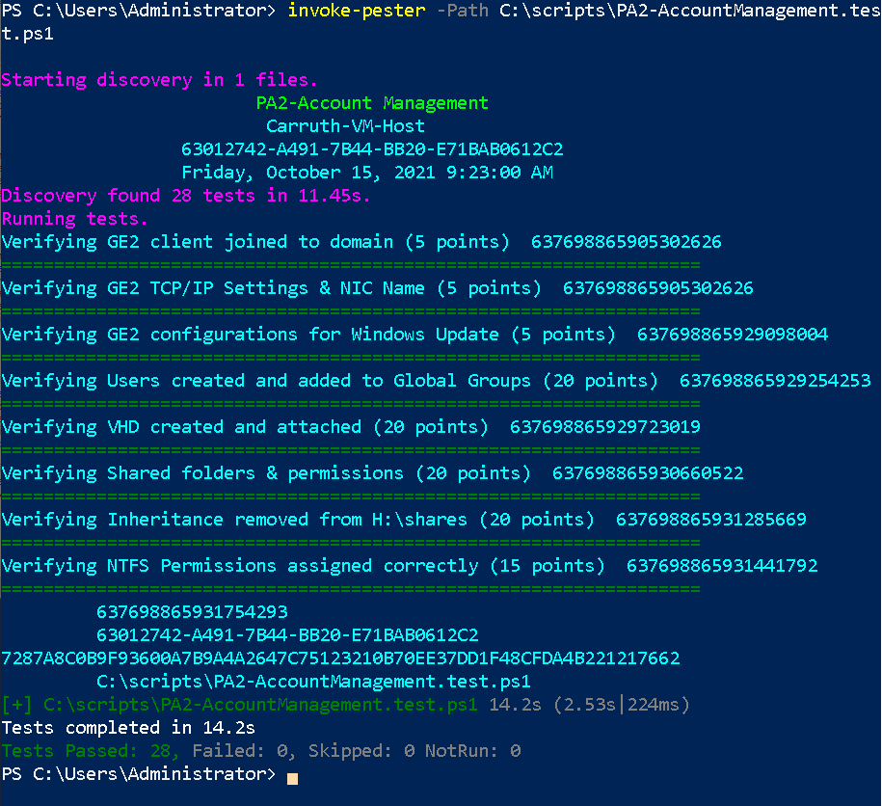

1. Capture a snippet that shows the PowerShell Command and all its output. If you must use more than one snippet to capture the output, you must have at least **one line of overlap** in the snippets. The text in the snippets **must be legible** when pasted into the Word document. The snippet should look like the image above. Name the document **PA2_*FirstName*_*LastName*.docx** where ***FirstName*** is your first name and ***LastName*** is your last name.
2. Upload **PA2_*FirstName*_*LastName*.docx** as the submission for this activity.